Written by Lucas Koh

- This set of queries was used to create the database used in the UWA Study Buddy website
- The queries roughly followed the below schema.

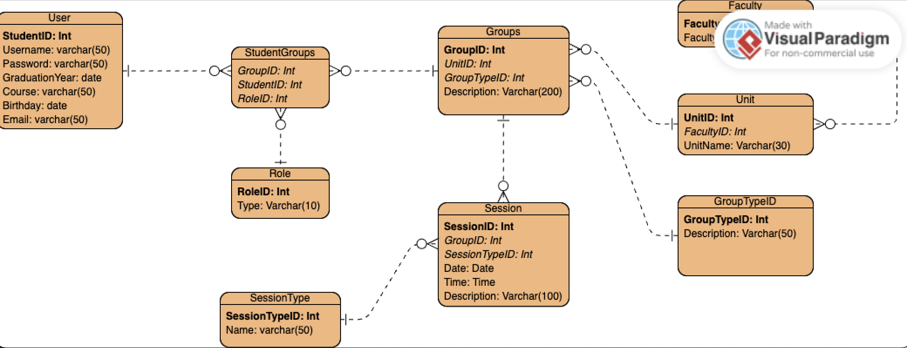

Queries

CREATE TABLE User (
StudentID INTEGER PRIMARY KEY,
Username TEXT CHECK (LENGTH(Username) <= 50),
Password TEXT CHECK(LENGTH(Password) <= 50),
GraduationYear INTEGER CHECK(GraduationYear BETWEEN 2026 AND 2100),
Course TEXT CHECK(LENGTH(Course) <= 50),
Birthday TEXT,
Email TEXT CHECK(LENGTH(Email) <= 50)
);

CREATE TABLE Role (
RoleID INTEGER PRIMARY KEY,
Type TEXT CHECK(LENGTH(Type) <= 20)
);

CREATE TABLE Faculty (
FacultyID INTEGER PRIMARY KEY,
Name TEXT CHECK(LENGTH(Name) <= 20)
);

CREATE TABLE Unit (
UnitID INTEGER PRIMARY KEY,
UnitName TEXT CHECK(LENGTH(UnitName) <=50),
FacultyID INTEGER,
FOREIGN KEY (FacultyID) REFERENCES Faculty(FacultyID)
ON DELETE RESTRICT
ON UPDATE RESTRICT
);

CREATE TABLE Groups(
GroupID INTEGER PRIMARY KEY,
UnitID INTEGER,
GroupTypeID INTEGER,
Description TEXT CHECK (LENGTH(Description) <= 200),
FOREIGN KEY (UnitID) REFERENCES Unit(UnitID) ON DELETE RESTRICT ON UPDATE RESTRICT,
FOREIGN KEY (GroupTypeID) REFERENCES GroupType(GroupTypeID) ON DELETE RESTRICT ON UPDATE RESTRICT
);

CREATE TABLE StudentGroups(
GroupID INTEGER,
StudentID INTEGER,
RoleID INTEGER,
PRIMARY KEY (GroupID, StudentID)
FOREIGN KEY (GroupID) REFERENCES Groups(GroupID) ON DELETE CASCADE ON UPDATE RESTRICT,
FOREIGN KEY (StudentID) REFERENCES User(StudentID) ON DELETE CASCADE ON UPDATE RESTRICT,
FOREIGN KEY (RoleID) REFERENCES Role(RoleID) ON DELETE RESTRICT ON UPDATE RESTRICT
);

CREATE TABLE SessionType (
SessionTypeID INTEGER PRIMARY KEY,
Name TEXT CHECK(LENGTH(Name) <= 50)
);

CREATE TABLE Session (
SessionID INTEGER PRIMARY KEY,
SessionDateTime INTEGER,
Description TEXT CHECK(LENGTH(Description) <= 50),
GroupID INTEGER,
SessionTypeID INTEGER,
FOREIGN KEY (GroupID) REFERENCES Groups(GroupID) ON UPDATE CASCADE ON DELETE RESTRICT,
FOREIGN KEY (SessionTypeID) REFERENCES SessionType(SessionTypeID) ON UPDATE CASCADE ON DELETE RESTRICT
);

